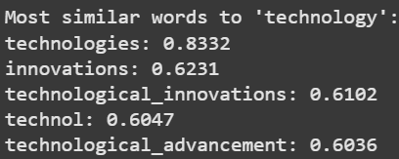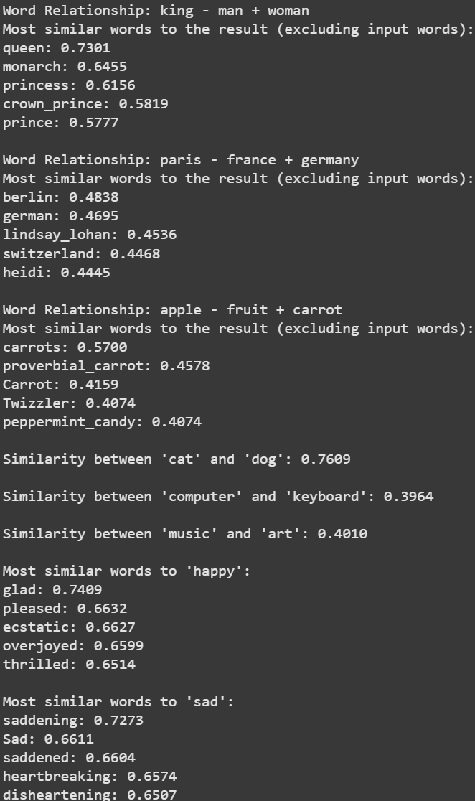

1

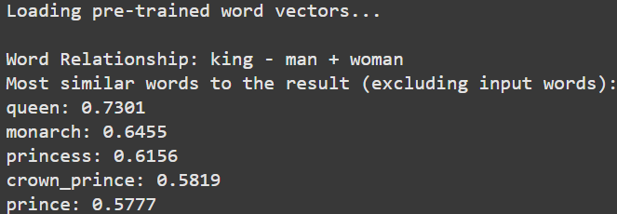

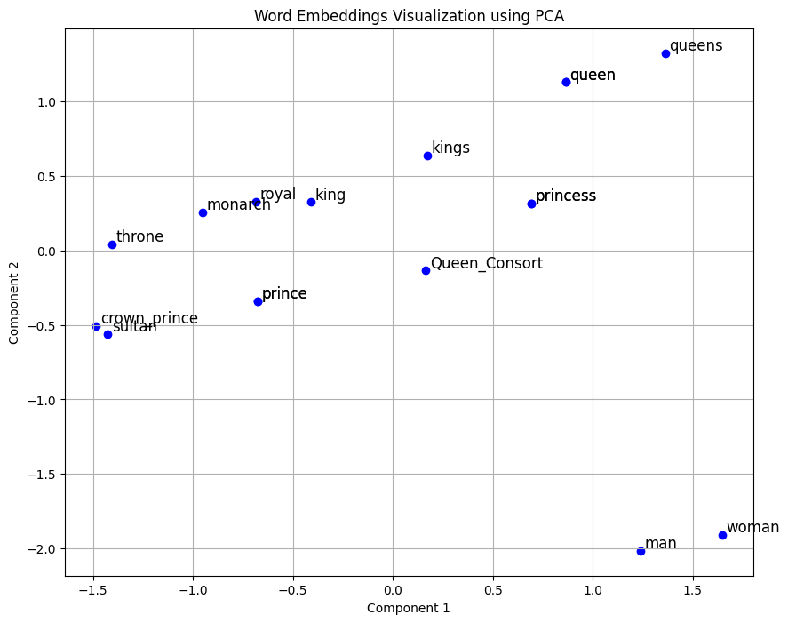

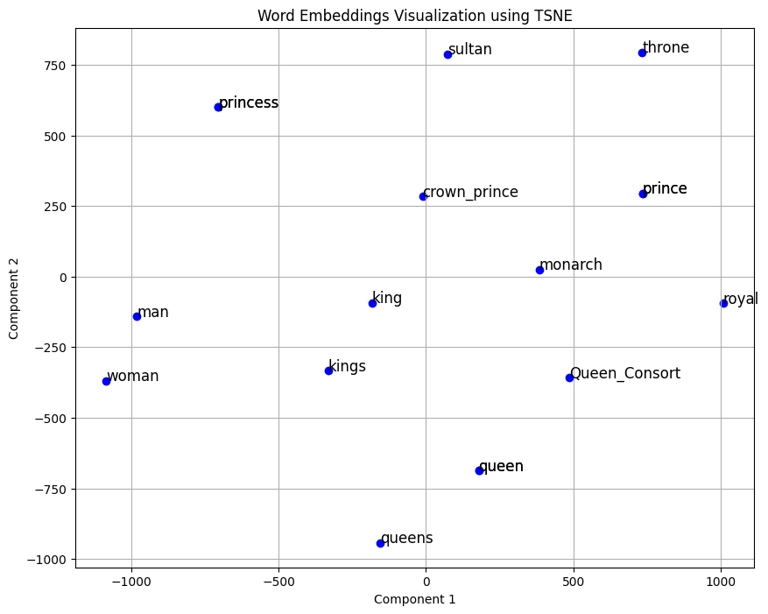

2

b.

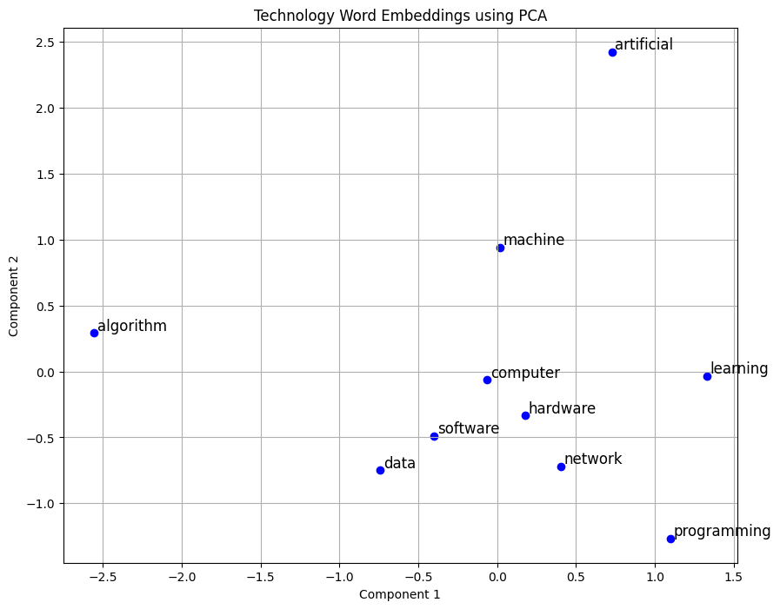

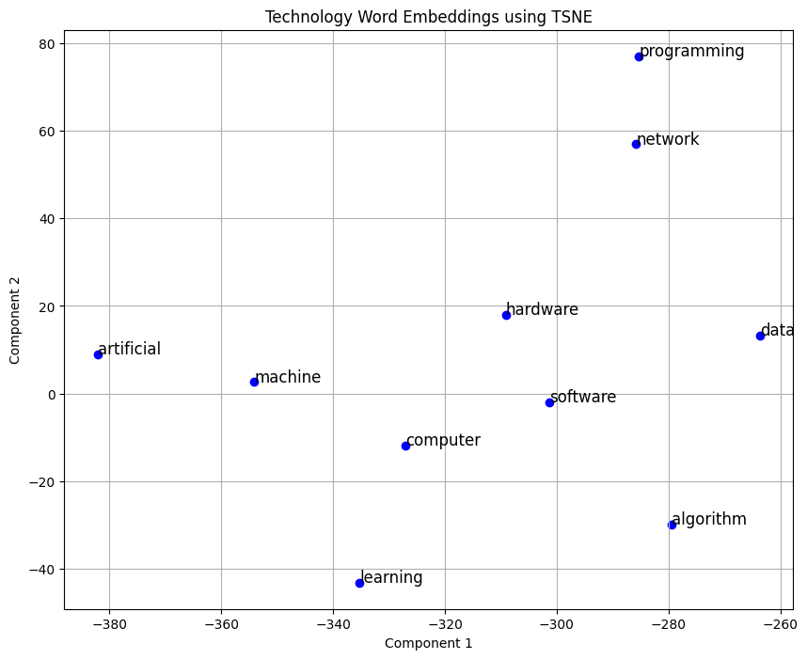

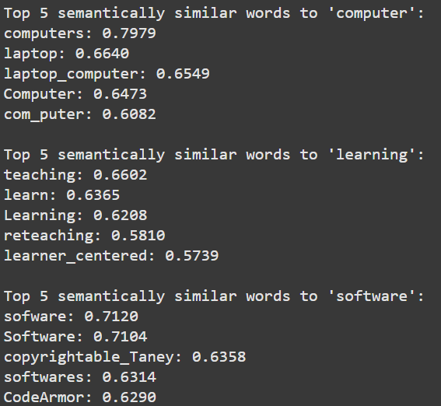

3.

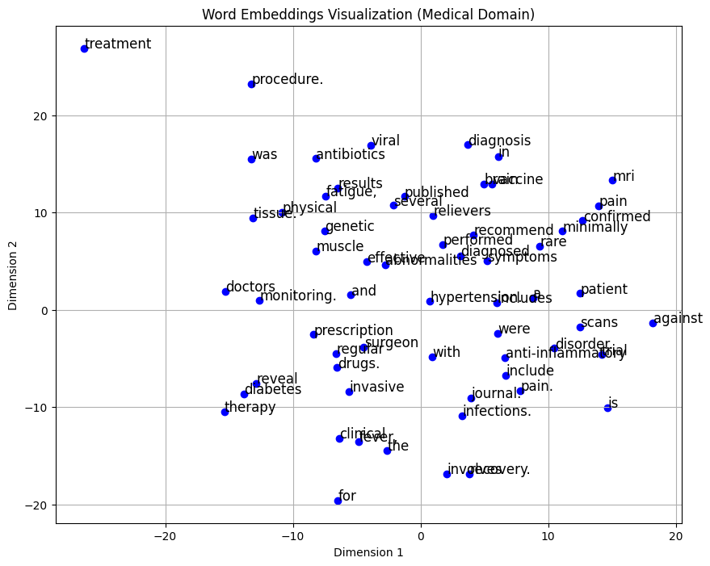

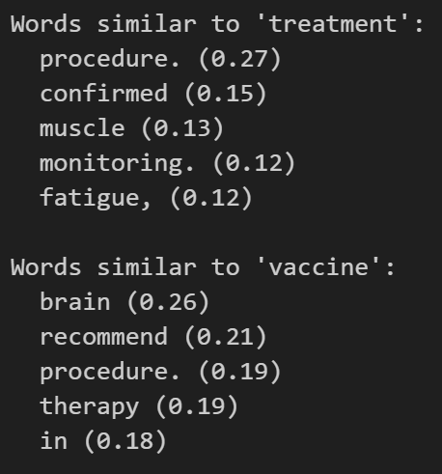

4.

Loading GPT-2 model...

Device set to use cpu

🔹 Original Prompt: Who is king.

Truncation was not explicitly activated but `max_length` is provided a specific value, please use `truncation=True` to explicitly truncate examples to max length. Defaulting to 'longest_first' truncation strategy. If you encode pairs of sequences (GLUE-style) with the tokenizer you can select this strategy more precisely by providing a specific strategy to `truncation`.

Setting `pad_token_id` to `eos_token_id`:50256 for open-end generation.

Replacing 'king' → 'prince'

🔹 Enriched Prompt: Who is prince .

Generating response for the original prompt...

Setting `pad_token_id` to `eos_token_id`:50256 for open-end generation.

Original Prompt Response:

Who is king. But this is no sin of God; it is a law that ought to be followed, and no man can commit such an act without taking responsibility. He never has done evil in the body, for God hath commanded it. He did good in the heart before, and in the mind, but that he have done good has no relation to the act itself. What is the reason for this? If we believe that God acts in the body, there is nothing which could lead a

Generating response for the enriched prompt...

Enriched Prompt Response:

Who is prince .... and is a man?" It is a question that brings out a curious paradox. At the very first period in which the prince is mentioned, his status and place of origin are not yet fully ascertained: he is a man living outside the sphere of official state power, as is obvious from his position as emperor by the emperor's decree, and is on the part of the other royal family, his family who are members in the family of the emperor, and whose

📊 Comparison of Responses:

Original Prompt Response Length: 424

Enriched Prompt Response Length: 450

Original Prompt Sentences: 4

Enriched Prompt Sentences: 5

5.

Loading pre-trained word vectors...

Word vectors loaded successfully!

Enter a seed word: cat

Generated Paragraph:

People often associate cat with cats and monkey. In the land of cat, pet was a common sight. A story about cat would be incomplete without rabbit and monkey. In the land of cat, pet was a common sight.

6.

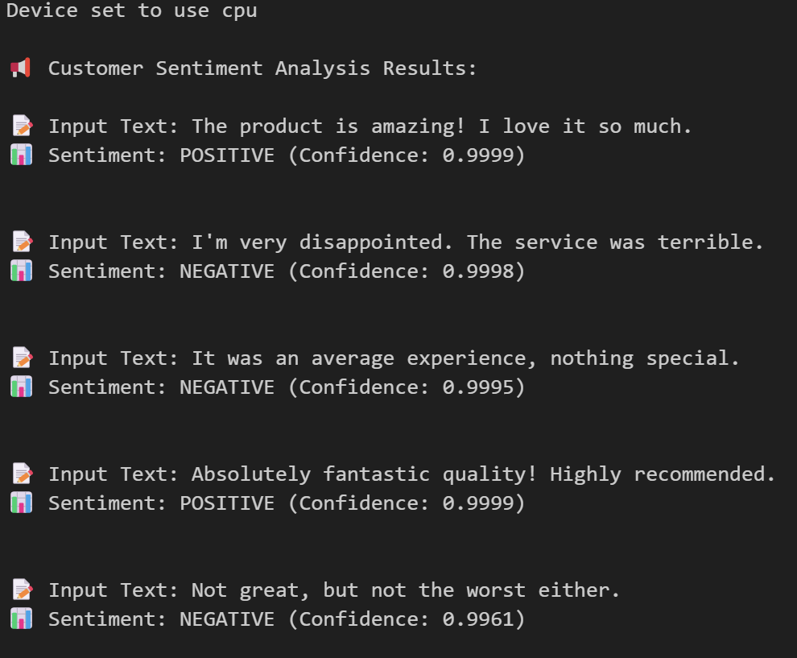

7.

📝 Original Text:

Artificial intelligence is rapidly transforming the world, influencing various industries including healthcare, finance, manufacturing, and education. AI-driven technologies are revolutionizing traditional processes by automating tasks, providing powerful insights, and enhancing efficiency. Machine learning algorithms analyze vast datasets to generate predictions, while natural language processing enables seamless communication between humans and machines. With advancements in deep learning, AI systems are now capable of understanding complex patterns, driving autonomous decision-making, and improving real-time analysis. Organizations are leveraging AI to optimize supply chains, detect fraud, personalize user experiences, and develop innovative solutions for global challenges. Despite its numerous benefits, AI also raises ethical concerns, including data privacy, bias in algorithms, and the impact on employment. Policymakers and industry leaders are working together to establish regulations that ensure AI is used responsibly and ethically. The future of AI holds immense potential, with ongoing research aimed at making it more transparent, trustworthy, and accessible for everyone. As AI continues to evolve, it will undoubtedly shape the way humans interact with technology, paving the way for a more interconnected and intelligent world.

📌 Summarized Text:

Default: Artificial intelligence is revolutionizing traditional processes by automating tasks, providing powerful insights, and enhancing efficiency. Despite its numerous benefits, AI also raises ethical concerns, including data privacy, bias in algorithms, and the impact on employment. Policymakers and industry leaders are working together to establish regulations that ensure AI is used responsibly and ethically.

High randomness: Artificial intelligence is revolutionizing traditional processes by automating tasks, providing powerful insights, and enhancing efficiency. Despite its numerous benefits, AI also raises ethical concerns, including data privacy, bias in algorithms, and the impact on employment. Policymakers and industry leaders are working together to establish regulations that ensure AI is used responsibly and ethically.

Conservative: Artificial intelligence is revolutionizing traditional processes by automating tasks, providing powerful insights, and enhancing efficiency. Despite its numerous benefits, AI also raises ethical concerns, including data privacy, bias in algorithms, and the impact on employment. Policymakers and industry leaders are working together to establish regulations that ensure AI is used responsibly and ethically.

Diverse sampling: AI-driven technologies are revolutionizing traditional processes by automating tasks, providing powerful insights, and enhancing efficiency. Despite its numerous benefits, AI raises ethical concerns, including data privacy, bias in algorithms, and the impact on employment. Policymakers and industry leaders are working together to establish regulations that ensure AI is used responsibly and ethically.

8.

Drive already mounted at /content/drive; to attempt to forcibly remount, call drive.mount("/content/drive", force_remount=True).  
✅ File loaded successfully!  
Dept. of CSE, RVITM Gen AI – BAIL657C 84  
🔑 Enter your Cohere API Key: ··········

:30: LangChainDeprecationWarning: The class Cohere was deprecated in LangChain 0.1.14 and will be removed in 1.0. An updated version of the class exists in the langchain-cohere package and should be used instead. To use it, run pip install -U langchain-cohere and import it as from langchain_cohere import Cohere.  
cohere_llm = Cohere(cohere_api_key=COHERE_API_KEY, model="command")

:54: LangChainDeprecationWarning: The method BaseLLM.predict was deprecated in langchain-core 0.1.7 and will be removed in 1.0. Use invoke instead.  
response = cohere_llm.predict(formatted_prompt)

📌 **Formatted Output** 📌  
Here is a written summary of the text you've provided:  
The text provides an overview of the core concepts from the book *The Courage to Teach* by Parker Palmer. The book discusses principles of effective teaching, with a particular focus on the teacher's role and inner life.

Here are three key points from the text:

1. Effective teaching starts with the teacher's own identity, values, and sense of purpose. Teaching is enhanced when educators connect with their students by exposing vulnerability and demonstrating authenticity.
2. The classroom environment, particularly the space between teachers and students, should be viewed as a "circle of trust," a community of truth where learning is a mutual exchange rather than a one-way transmission of information. It is essential for teachers to build meaningful relationships with their students and help them feel connected to the subject they are learning.
3. Rather than acting as merely authoritative figures, teachers should view themselves as facilitators who guide students through the learning process. Teachers should encourage critical thinking and curiosity and prioritize inspiring students over merely transmitting knowledge.

The sentiment of the document itself is predominantly positive, as it discusses ideas and concepts of effective teaching practices that enhance the learning experience for students.

9.  
Institution:  
**Massachusetts Institute of Technology (MIT)**

Founder: **N/A**

Founded:  
MIT was established in response to the increasing industrialization of the United States, adopting a European polytechnic university model that emphasizes laboratory instruction in applied science and engineering. It is one of three private land-grant universities in the U.S., alongside Cornell University and Tuskegee University. The institute boasts an urban campus spanning more than a mile along the Charles River and operates several off-campus research facilities, including the **MIT Lincoln Laboratory, Bates Center, and Haystack Observatory**, as well as affiliated institutions such as the **Broad and Whitehead Institutes**.

Branches: **N/A**

Number of Employees: **N/A**

Summary:  
The **Massachusetts Institute of Technology (MIT)** is a **private research university** located in **Cambridge, Massachusetts, USA**. Established in **1861**, MIT has played a pivotal role in shaping modern technology and science. Over the years, the institute has remained at the forefront of innovation, contributing significantly to advancements in various fields, including engineering, artificial intelligence, physics, and biotechnology.

10.

Enter your Cohere API Key: ··········

You:

Can you explain section 302 of IPC

<ipython-input-4-1e995a86ae5a>:49: LangChainDeprecationWarning: The method `BaseLLM.predict` was deprecated in langchain-core 0.1.7 and will be removed in 1.0. Use :meth:`~invoke` instead.

response = cohere_llm.predict(formatted_prompt) Dept. of CSE, RVITM Gen AI – BAIL657C 103

Section: 302 of the Indian Penal Code states that "whoever commits murder shall be punished with imprisonment for life, or with imprisonment of either description for a term which may extend to ten years, and shall also be liable to fine."

It defines murder as

Explanation: The involuntary killing of a human being, by a person acting with the intention of causing death or causing such bodily injury as is likely to cause death.

Murder is considered a more severe crime than manslaughter because there must be an element of intent present to establish a murder charge. In order for someone to be convicted of manslaughter, murder must be reclassified as such based on three scenarios:

1. The accused actually lit the fire that led to the death of the victim.

2. The accused intentionally provided a substance or object that resulted in the victim's death.

3. By intent, the accused injured the victim in such a way that they reasonably believed would likely result in death.

While this section covers the general definition of murder, it is important to note that there are different types of murder defined by Indian law. These include:

- Murder under section 302 - Defined as a premeditated and intentional killing of another person.

- Culpable homicide